Magdalene Fields Golf Club

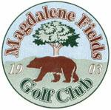Berwick upon Tweed Northumberland TD15 1NE
Tel 01289 306130 secretary.m.f.g.c@hotmail.co.uk

Father McHugh Open

Sunday 29 May 2022
2 Man Scramble Min age 18yrs
Entry Fee £25 per team
Closing Date for entries 29 May 2022
All players must have an active CONGU handicap

TO BOOK USE OUR
ONLINE BOOKING FACILITY AT
www.magdalene-fields.co.uk
OR
CALL 01289306130

ENTRIES ONLY ACCEPTED WHEN ACCOMPANIED BY ENTRY FEE.

ALL CASH PRIZES
PROOF OF HANDICAP IS REQUIRED FROM ALL PRIZE WINNERS
SPONSORED BY

